﻿

TD Energy Storage System:

Modeling of Optimization Problems

**﻿** **﻿E-PiCo Master Author: Yassir DAHMANE**

1. **EV Charging Scheduling**

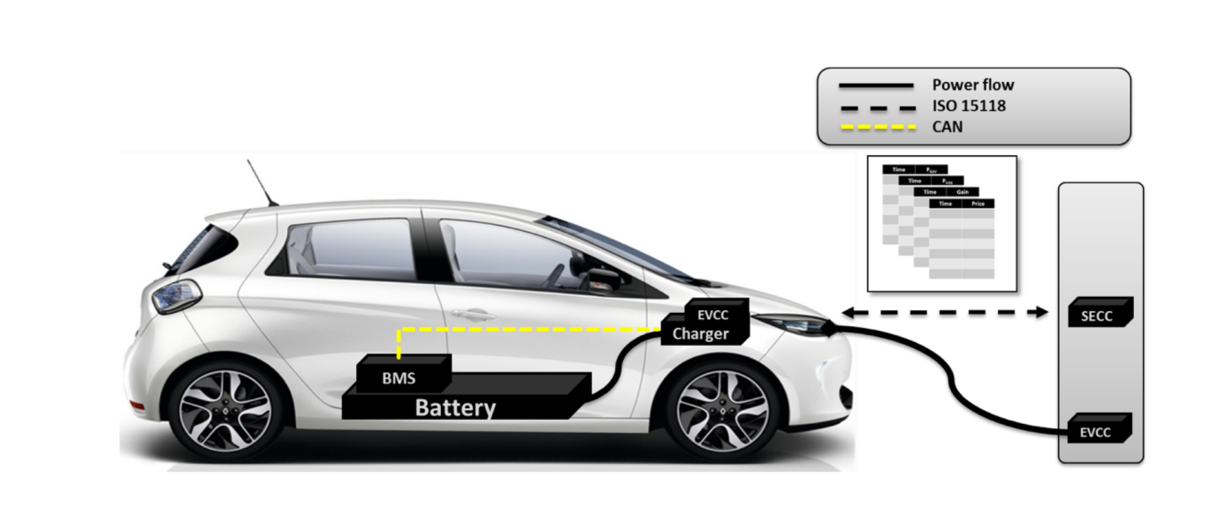

**﻿**An Electric vehicle (EV) with a Li-ion battery capacity of 60kWh. Considering the

time dependence of the energy prices, the EV owner’s aim to reduce the charging bill

of his EV. The energy cost for each kWh is given as follow for the eight hours of the charging session: [9,8,7,5,7,6,9,10] c€/kWh. c€ = 0.01€

The EV is available for home charging from 10h00 to 18h00 and the length of the time-slots is ∆t = 1h. The charging station the EV with a maximal power of 11kW. The EV arrives at home with a SOC of 30%. The EV owner’s aims to reach the desired SOC of 70% before 18h00.

﻿1. Formulate the objective function using the power as decision variable and the charging cost as an optimization parameter.

2. Formulate the constraint of power limitation of the charging station.

3. Formulate the constraint of the energy requirement of the EV.

$$\sum_{1}^{8}{P_{i}}≥ E_{req} with E_{req}=\left(0.7-0.3\right)×60=24kWh$$

1. **Bidirectional EV Charging Scheduling**

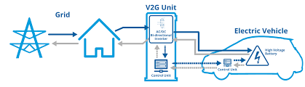

An Electric vehicle (EV) with a Li-ion battery capacity of 60kWh. Considering the

time dependence of the energy prices, the EV owner’s aim to reduce the charging bill

of his EV using the V2G feature (bidirectional charging). The energy cost for each kWh is given as follow for the eight hours of the charging session: [9,8,7,5,7,6,9,10] and the remuneration for V2G is [2,4,6,8,12,14,14,14] c€/kWh c€ = 0.01€

The EV is available for home charging from 10h00 to 18h00 and the length of the time-slots is ∆t = 1h. The charging station the EV with a maximal power of 11kW. The EV has an initial SOC of 40%. The EV owner’s aims to reach the desired SOC of 60% before 18h00. To extend the battery lifetime the EV owner prefers to keep always the SOC between 20% and 80%

﻿1. Formulate the objective function using the power as decision variable and the charging cost and discharging profit as an optimization parameter.

2. Formulate the constraint of power limitation of the charging station.

3. Formulate the global constraint of SOC limitation.

4. Formulate the constraint of the final SOC requirement of the EV.

*Or*

5. Formulate the constraint of SOC limitation used by the EV owner.

$$∀ i∈ ⟦1,8⟧ 0.2≤SOC_{i}≤0.8$$

Appendix:

Linearization of ${ P}_{i}^{c}×P_{i}^{d}=0$

